Postprocessor User's Guide

- Following the processor to set the CUTCOM parameter

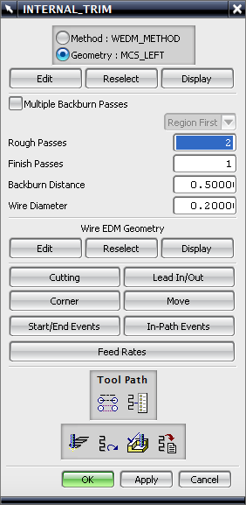
- Start/End Events
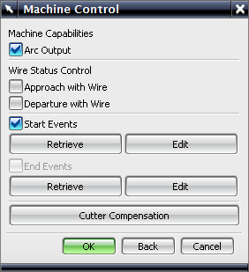
- Cutter compensation

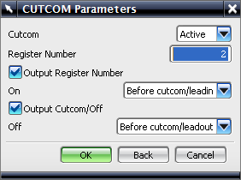
- Check the “Output Register Number” on and set it as “before cutcom/leadin”
- Check the “Output Cutcom/Off “ on and set it as “before cutcom/leadout”

2. Following the processor to set the E & D parameter

